### **Project Database Systems**

### **Submitted To Sir Aaveed Anwer**

### **Submitted By WAFAQ Fatima**

### **Roll Number 22024119-092**

### **BATCH 2022 FALL (Section A)**

### **THURSDAY, June 27, 2024**

### **Department of Computer Science**

### 



### 

### ***SALARY MANAGEMENT SYSTEM***

### 

### 

### **Introduction**

The Salary Management System is a comprehensive project designed to streamline the processes involved in managing employee compensation within an organization. This system provides functionalities for tracking employee details, managing departmental assignments, handling salary calculations, documenting promotions, and maintaining salary history records. By integrating these processes, the system ensures accurate and efficient management of employee compensation, ultimately aiding in the smooth operation of HR and payroll departments.

### **Key Tables**

1. **EMPLOYEE**: This table holds fundamental information about employees, including their personal details, departmental assignments, hire dates, and current positions. It serves as the primary source of employee-related data within the system.
   * **Attributes**: EmployeeID (PK), FirstName, LastName, DepartmentID (FK), HireDate, CurrentPosition.
2. **DEPARTMENT**: This table contains information about various departments within the organization. It helps in categorizing employees based on their departmental assignments.
   * **Attributes**: DepartmentID (PK), DepartmentName.
3. **SALARY**: This table manages the salary details for each employee, including base salary, bonuses, deductions, and net salary. It ensures that salary computations are accurately recorded and accessible for payroll processing.
   * **Attributes**: SalaryID (PK), EmployeeID (FK), BaseSalary, Bonus, Deductions, NetSalary, PayDate.
4. **PROMOTION**: This table records employee promotions, capturing information about old and new positions, along with the dates when promotions occurred. It helps in tracking career advancements within the organization.
   * **Attributes**: PromotionID (PK), EmployeeID (FK), OldPosition, NewPosition, PromotionDate.
5. **SALARYHISTORY**: This table maintains a history of salary changes for employees, documenting old and new base salaries and bonuses, along with the effective dates of these changes. It is crucial for maintaining a record of compensation evolution over time.
   * **Attributes**: HistoryID (PK), EmployeeID (FK), OldBaseSalary, NewBaseSalary, OldBonus, NewBonus, EffectiveDate.

### **Conclusion**

The Salary Management System is an essential tool for organizations aiming to enhance their payroll and HR operations. By leveraging the information stored in these key tables, the system facilitates accurate salary calculations, ensures transparent promotion tracking, and maintains comprehensive salary histories, thereby supporting efficient and effective employee compensation management.

For more advanced features and customizations, consider exploring alternatives like [HIX.AI](https://hix.ai/chat), a versatile platform for managing chat-based interactions and projects.

**ERD DIAGRAM:**

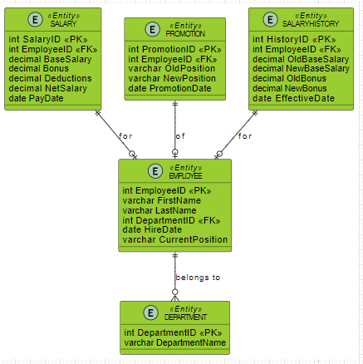

**CREATE DATABASE:**



**CREATE TABLES:**

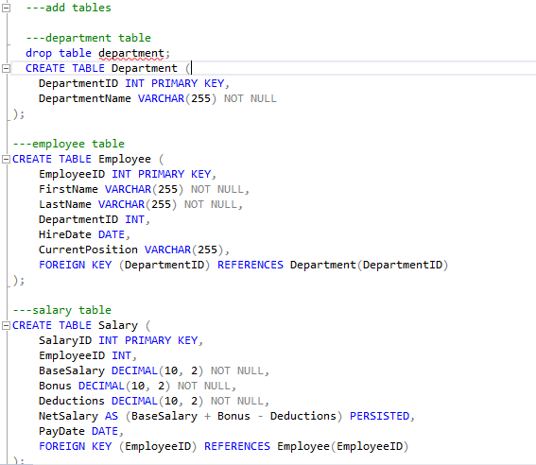

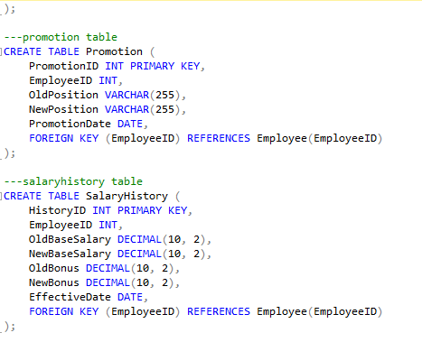

**INSERT VALUES IN TABLES:**

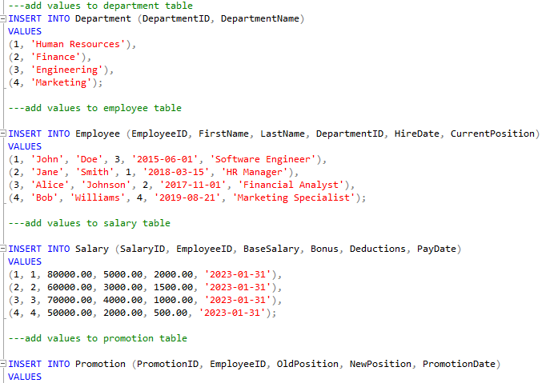

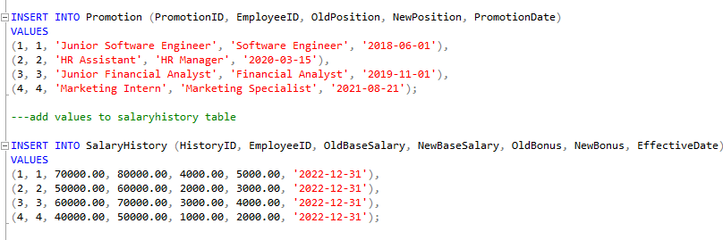

**PROCEDURES:**

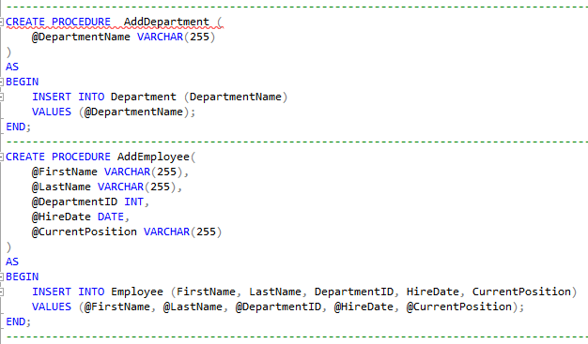

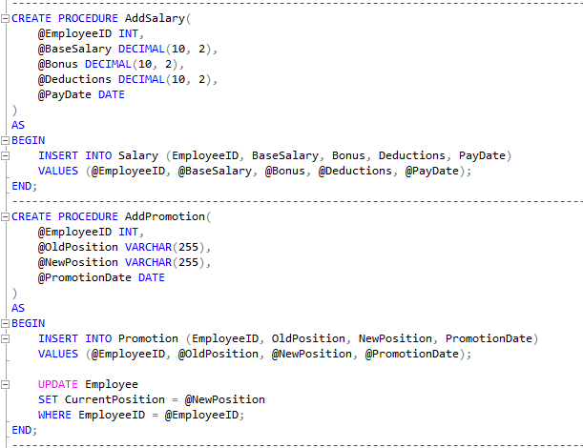

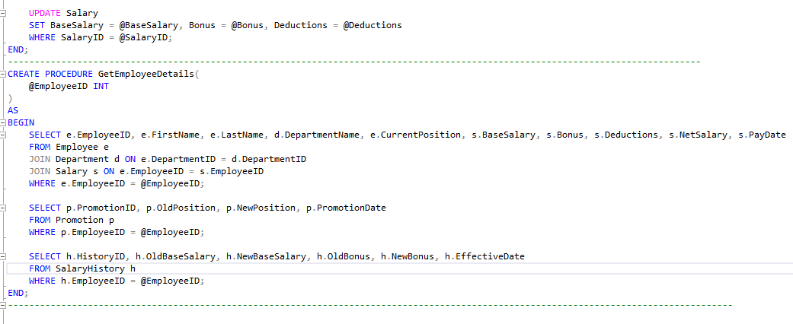

**RESULTS:**

**EXEC show department data :**



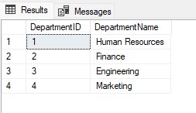

**EXEC show employee data :**



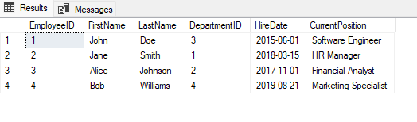

**EXEC show salary data :**



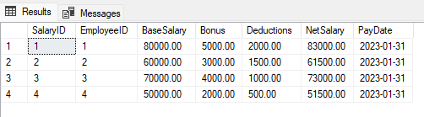

**EXEC show promotion data :**



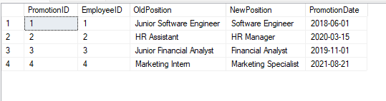

**EXEC show salaryhistory data :**



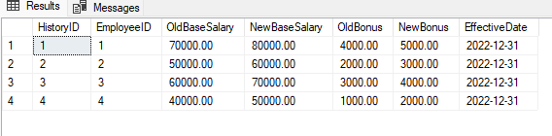

**Queries:**

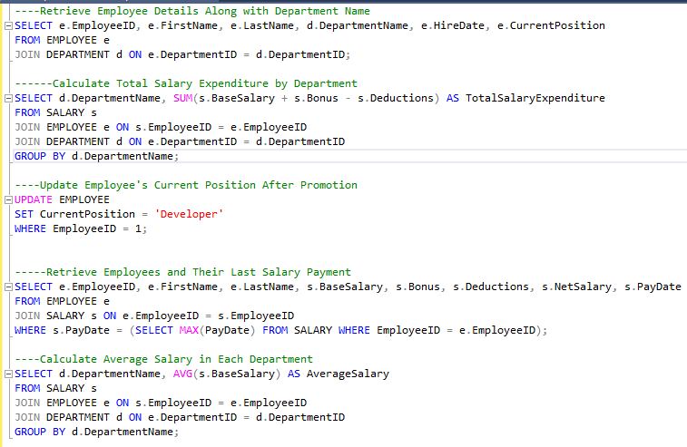

**Output:**

**Retrieve Employee Details Along with Department Name**

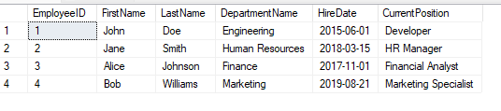

**Calculate Total Salary Expenditure by Department**

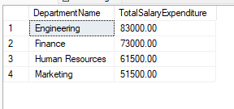

**Update Employee's Current Position After Promotion**

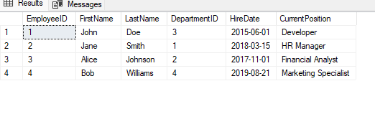

**Retrieve Employees and Their Last Salary Payment**

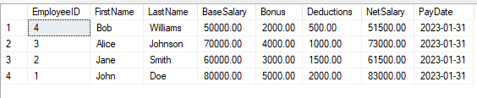

**Calculate Average Salary in Each Department**

